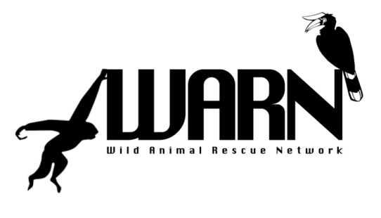
6th East and Southeast Asian
Wild Animal Rescue Network Conference
“WARN 2014”
23-27 November, 2014
Hong Kong SAR, China

“Challenges Faced during Long Term Maintenance of Rescued Wildlife”

INVITATION

The Kadoorie Farm and Botanic Garden Fauna Conservation Department is pleased to host the 6th WARN Conference in Hong Kong SAR from the 23rd to 27th November, 2014.

We hereby warmly invite you to participate in the 6th WARN Conference with this year’s theme being the “Challenges Faced during Long Term Maintenance of Rescued Wildlife”.

We aim to further enhance sharing of experiences through practical workshops and presentations.

WARN is now a registered Non-Government Organisation. Therefore, it was decided during the 5th WARN Conference, that an election to choose permanent Board Members to replace the interim Board, will be conducted during the 6th WARN Conference.

VENUE

Conference hotel: | Regal Riverside Hotel  Address: 34-36 Tai Chung Kiu Road, Shatin, Hong Kong  http://www.regalhotel.com/regal-riverside-hotel/en/home/home.html
Conference venue: | Kadoorie Centre  Address: Lam Kam Road, Shek Kong, Yuen Long, New Territories, HK  http://www.cedars.hku.hk/hkukc/

REGISTRATION

To register for WARN 2014, please fill out the registration form and return it via email before 30th September, 2014 to the Secretariat at: warn2014@kfbg.org

The Registration Fee for twin sharing is:
- US$250 (HKD2000) for Early Bird (on or before 31 July 2014)
- US$300 (HKD2400) after the 31st July.

For those who desire their own room the Registration Fee is:
- US$350 (HKD2800) for Early Bird (on or before 31 July 2014)
- US$400 (HKD3200) after the 31st July.

The Registration Fee includes:
- Four (4) days attendance at the conference
- Accommodation (twin share) for five (5) nights at Regal Riverside Hotel
- Breakfast, Lunch and Dinner, and coffee-breaks on conference days
- Visit to WWF Mai Po Nature Reserve

We regret to advise that the registration fee is fixed, and no discounts or refunds are allowed for shorter stays or for opting out of the programme.

Note that we have reserved 15 rooms on a first come first served basis for overseas participants. If all the rooms have been taken up and you are still keen to participate in the conference, we may try to obtain rooms for you but that may incur extra charges (November is high tourist season in Hong Kong) and we will advise you accordingly. Therefore please register early to avoid disappointment.

PAYMENT METHOD

Via Bank Transfer

We prefer that registration fees be sent via Telegraphic Transfer, T/T, made payable to:

Bank Name and Address | HSBC, 1 Queen's Road Central, Hong Kong
Account Name | Kadoorie Farm & Botanic Garden Corporation
Account Number | 511316689001
Swiftcode | HSBC HK HHH KH

Please indicate “WARN 2014 Fees” for the payment. Bank charges are to be paid by the participant. Kindly inform the Secretariat via EMAIL once the payment has been made, with a scan of the T/T receipt.
Cash On Arrival
For participants who are not able to send the registration fees via T/T, please indicate in the form that you will make payment upon arrival

CONFERENCE TOURS

During the conference, participants will visit:
- Mai Po Nature Reserve (http://www.wwf.org.hk/en/getinvolved/gomaipo/)
- Kadoorie Farm & Botanic Garden (http://www.kfbg.org/kfb/homepage.xml?lang=en)

PRESENTATIONS AND ABSTRACTS

The organisers invite presentations from WARN 2014 Conference participants, with a focus on the Conference Theme. The WARN 2014 Organising Committee will review, select and confirm the final list of speakers for the conference. Selected speakers will be notified by 27th October 2014.

Oral presentations are planned for 30 minutes which includes questions and answers. Abstracts are to be submitted by 15th October 2014 to warn2014@kfbg.org

Format and layout instructions:
- Abstracts should be in English, around 500 words (including title, author, affiliation)
- Font 12 points, Times New Roman, single spaced
- Title in bold and capital letters above author’s name, affiliation, email address
- Please do not include figures, tables and special mathematical symbols

TRAVEL AND OTHER INFORMATION

- Participants are advised to arrive in Hong Kong on the 23rd November 2014.
- Hotel Check-in time at the venue is at 2:00 pm.
- There will be a registration desk manned from 1:00 pm on the 23rd November at the Conference Hotel. Please email us your travel arrangements so that we know when to expect you at the hotel.
- There is a shuttle bus service between the Hong Kong International Airport and the Regal Riverside Hotel. It charges HKD 130 per person per trip (http://shuttle.regalhotel.com/?rlang=en-US).
- During the Conference, we have arranged a shuttle bus to bring you to the Conference Centre which leaves the hotel at 8:15 am (the journey is approximately 30 minutes). If you miss this bus, you will have to take a taxi to the Kadoorie Centre from the hotel which should be around HKD150 per trip.

Hong Kong provides visa-free stays for most countries, for up to 90 days. Please check what is applicable for you, if you need any assistance or an invitation letter please contact the secretariat in advance.

ENQUIRIES

For enquiries and further information please contact the Secretariat at: warn2014@kfbg.org

