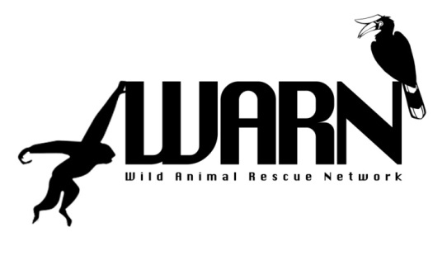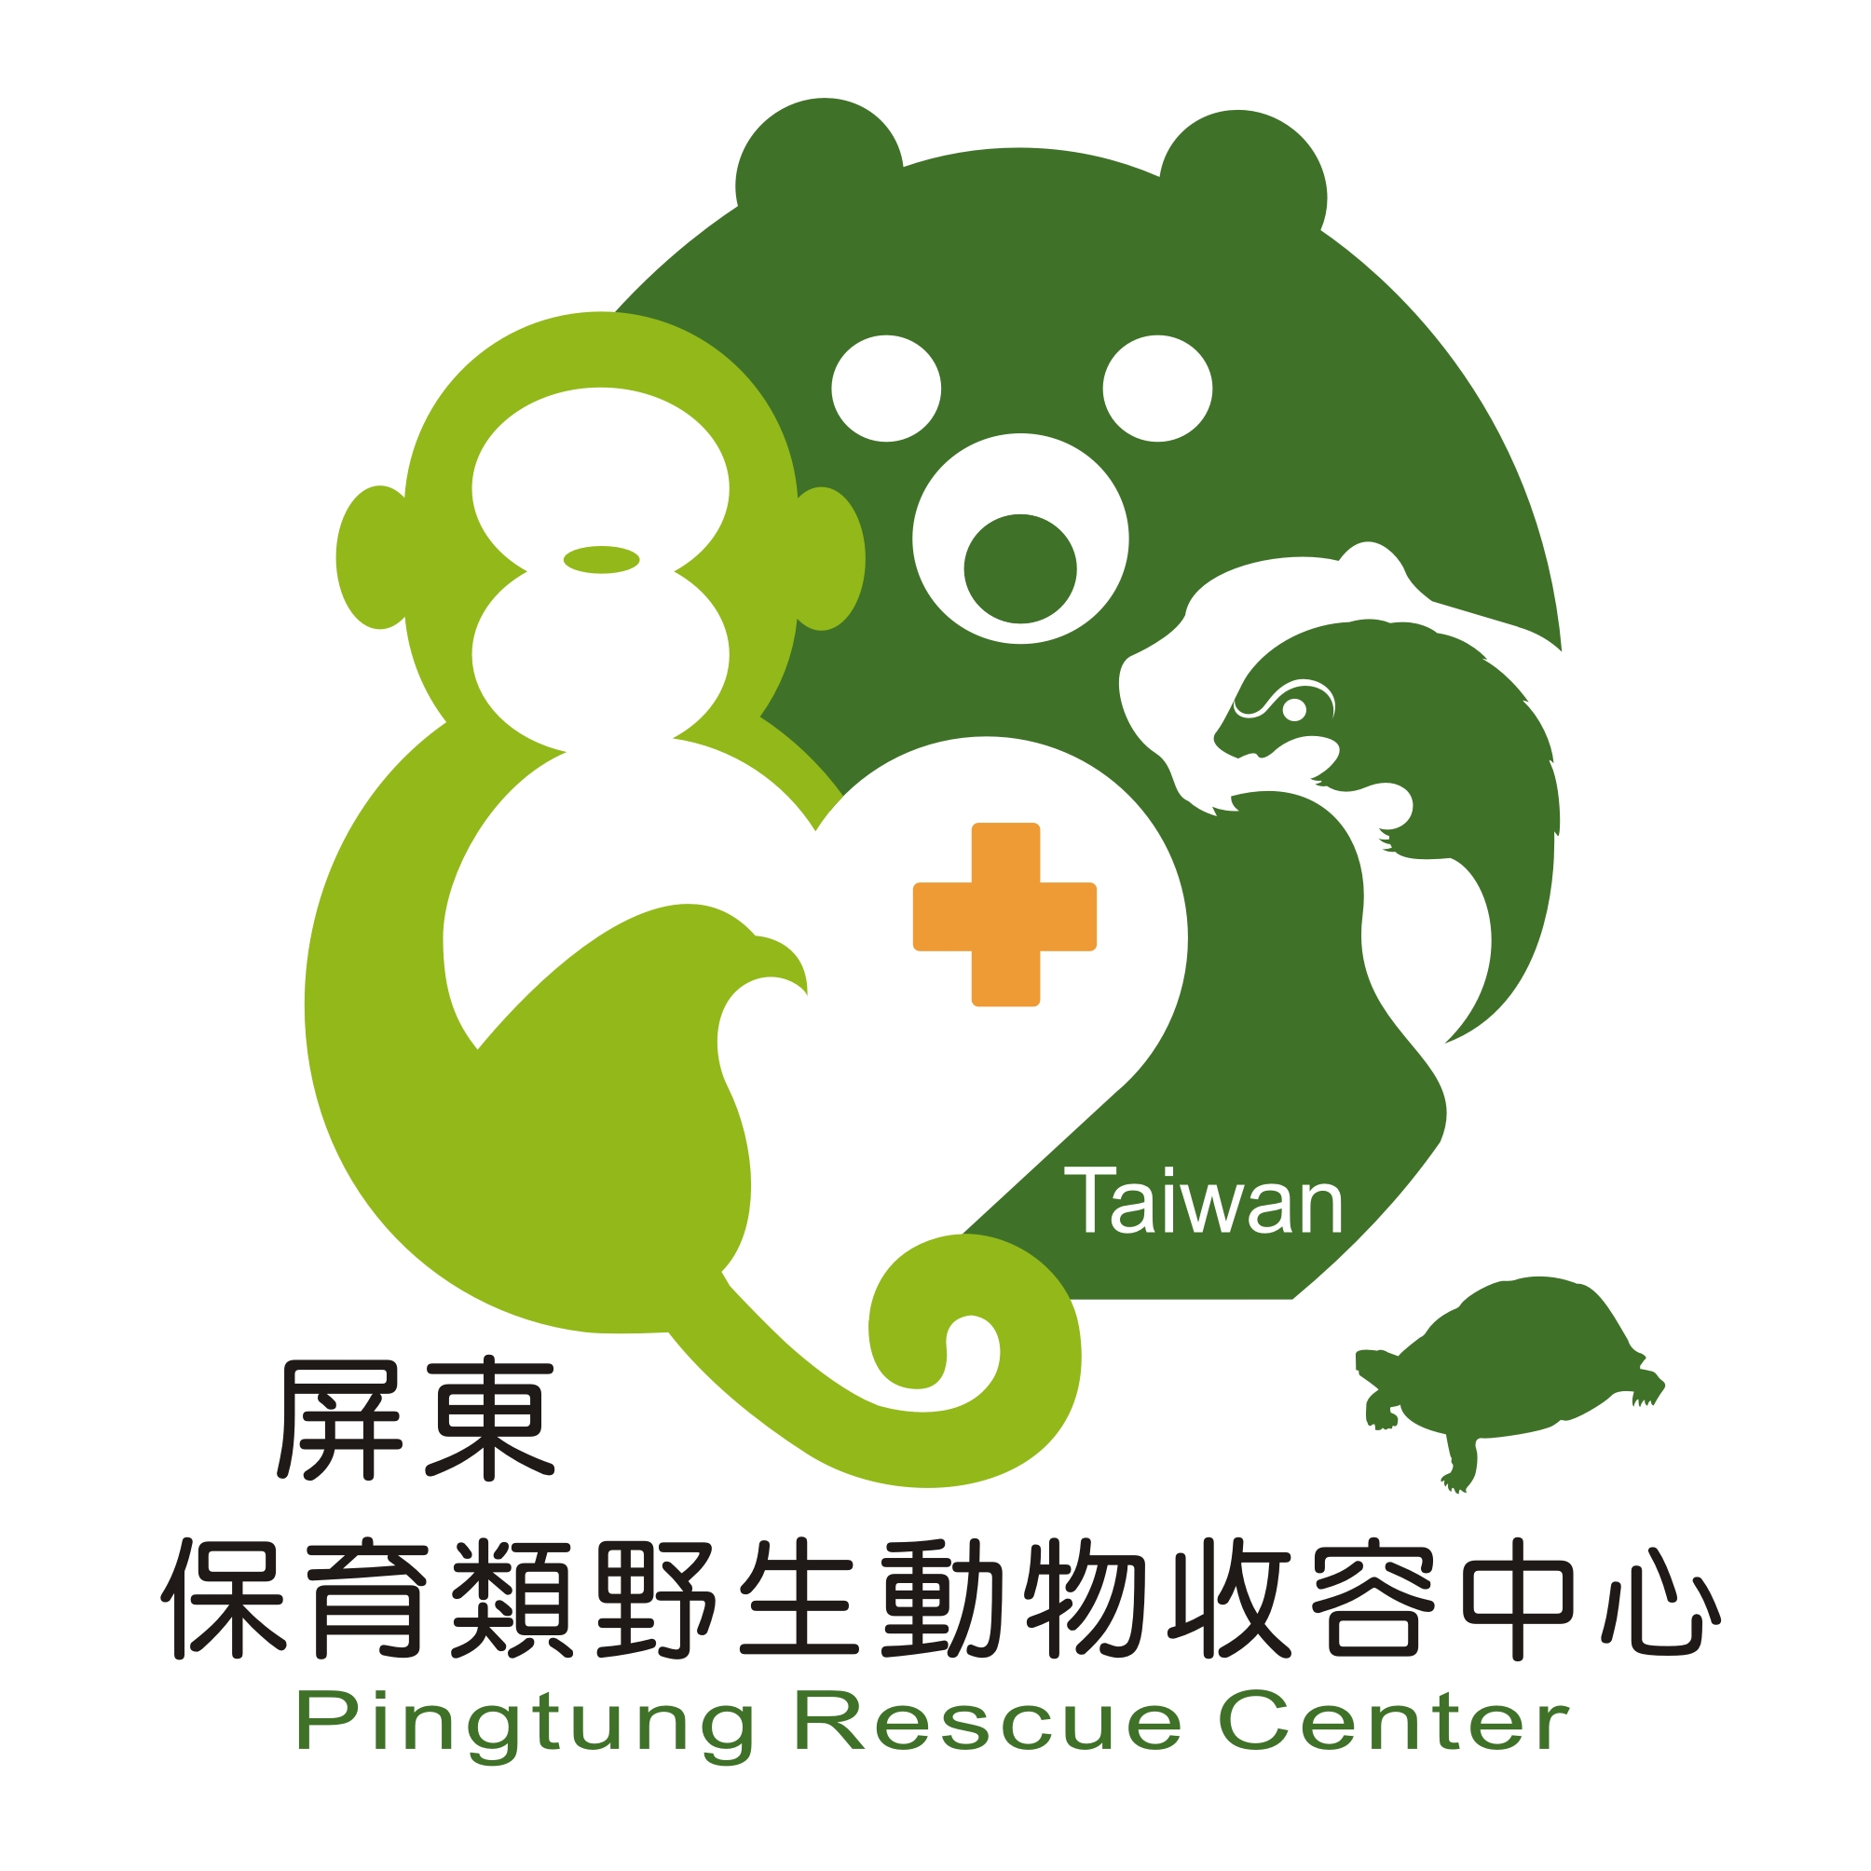
WILD ANIMAL RESCUE NETWORK CONFERENCE
9 - 13th November 2018
Pingtung Rescue Centre, Taiwan

Tentative Program Schedule
Date: 9 November 2018, First day
Time | Activities
13:00-13:45 | Pick up the guests and participants at the Kaoshsiung International Airport
14:30-15:15 | Pick up the guests and participants at the High Speed Rail Kaohsiung Station to NPUST
16:30 | Check in the NPUST Guest House
16:30- 17:30 | Refresh time
17:30 | Dinner (Dinner box will be managed)

Technical Program
Date:10 November 2018, Second Day
Time | Activities | Moderator
8:30-9:00 | Registration
9:00-9:50 | Keynote Lecture I on Theme : Illegal Wildlife Trade and Rehabilitation of Rescued Animals (to be arranged, TBA) | TBA
9:50-10:00 | Group Picture Session
10:00-10:20 | Tea/ coffee break
10:20-12:00 | 3 Presentations on sub-theme 1: Rescue and Rehabilitation | 25 Min. for presentation and 5 Min. for questions
12:00-13:30 | Lunch
13:30-15:00 | 3 Presentations on sub-theme 2: Disease and parasites of rescued animal | 25 Min. for presentation and 5 Min. for questions
15:00-15:20 | Tea/ coffee break.  Poster Session
15:20- 17:00 | 3 Presentations on sub- theme 3: Illegal wildlife trade and its impact  Poster Session | 25 Min. for presentation and 5 Min. for questions
17:30-20:00 | Welcome Dinner
Date: 11 November 2018, Third day
Time | Activities |  | Moderator
9:10-10:00 | Keynote Lecture II on Theme : Illegal Wildlife Trade and Rehabilitation of Rescued Animals (to be arranged, TBA)
Technical Session continue……
10:00-10:20 | Tea/ coffee break
10:20-12:30 | Visit the Pingtung Rescue Center for Endangered Wild Animals |  | PTRC
12:30-13:30 | Lunch
13:30-15:00 | 3 presentations on sub- theme 4: Conservation awareness and outreach programs |  | 25 Min. for presentation and 5 Min. for questions
15:00-15:20 | Tea/ coffee break.  Poster Session
15:20- 17:00 | Board meeting and election of the second board memebrs |  | WARN
Date:12 November 2018, 4th Day
9:10-10:00 | Keynote Lecture III on Theme : Illegal Wildlife Trade and Rehabilitation of Rescued Animals (to be arranged, TBA)
Technical Session continue.….
10:00-10:20 | Tea/ coffee break
10:20-12:00 | TBA
12:00-15:00 | Lunch box on bus
15:00-16:30 | Visit to Taiwan Endemic Species Research Institute, Nantou, Central Taiwan.
16:30 | Check in guest house
17:30-20:00 | Farewell party.
Date: 13 November 2018, 5th Day
Time | Activities |  | Moderator
9:30- 12:30 | Visit to rescue and education facilities of the Taiwan Endemic Species Research Institute
12:30-13:30 | Lunch
13:30-16:30 | Departure of Participants to High Speed Rail Taichung Station or Kaohsiung International Airport

Note: The registration fee covers: all meals and accommodations for 9-13 November. Also, covers local transportations during the arrival, travel to Nantou and departures from Nantou to Taichung or Kaohsiung on Nov. 13.

